Mann Whitney python代码

from ucimlrepo import fetch_ucirepo
import pandas as pd
from scipy.stats import mannwhitneyu
cdc = fetch_ucirepo(id=891)
df = cdc.data.features.copy()
df['Diabetes_binary'] = cdc.data.targets
group0 = df[df['Diabetes_binary'] == 0]
group1 = df[df['Diabetes_binary'] == 1]
for col in ['BMI', 'MentHlth', 'PhysHlth']:
u, p = mannwhitneyu(group0[col].dropna(),
group1[col].dropna(),
alternative='two-sided')
print(f'{col:<10} | U = {u:>12.2f} | p = {p:>12.6f}')
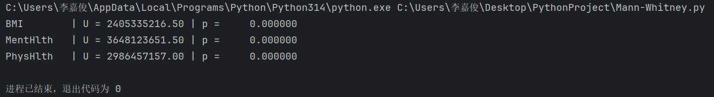
这里最好加上为什么只选取了BMI，MentHlth，PhysHlsh三个变量来做Mann-Whitney检验。
原因：只有这三个变量的取值范围比较大，对于糖尿病指示指标为0和1的两组数据，考虑这三个变量的位置参数是比较合理的，剩下的变量参数适合做分类而不适合比较位置参数。

Logistic回归代码（为什么不做普通线性回归是因为是否为糖尿病的指示变量取值只有两个，不适合做普通线性回归）
from ucimlrepo import fetch_ucirepo
import pandas as pd
import numpy as np
import seaborn as sns
import matplotlib.pyplot as plt
from sklearn.linear_model import LogisticRegression
from sklearn.metrics import (classification_report, roc_auc_score,
roc_curve, confusion_matrix, accuracy_score)
from sklearn.model_selection import train_test_split
cdc = fetch_ucirepo(id=891)
X = cdc.data.features
y = cdc.data.targets
X_train, X_test, y_train, y_test = train_test_split(
X, y, test_size=0.25, random_state=42, stratify=y)
logit = LogisticRegression(max_iter=1000)
logit.fit(X_train, y_train)
y_pred = logit.predict(X_test)
y_pred_proba = logit.predict_proba(X_test)[:, 1]
print(classification_report(y_test, y_pred))
print(f'Accuracy : {accuracy_score(y_test, y_pred):.3f}')
print(f'AUC : {roc_auc_score(y_test, y_pred_proba):.3f}')
fpr, tpr, _ = roc_curve(y_test, y_pred_proba)
plt.figure(figsize=(5, 4))
sns.lineplot(x=fpr, y=tpr, label=f'ROC (AUC = {roc_auc_score(y_test, y_pred_proba):.3f})')
plt.plot([0, 1], [0, 1], 'k--')
plt.xlabel('FPR')
plt.ylabel('TPR')
plt.title('ROC Curve')
plt.tight_layout()
plt.show()
plt.figure(figsize=(4, 3))
sns.heatmap(confusion_matrix(y_test, y_pred),
annot=True, fmt='d', cmap='Blues',
xticklabels=['No', 'Diabetes'],
yticklabels=['No', 'Diabetes'])
plt.xlabel('Predicted')
plt.ylabel('Actual')
plt.title('Confusion Matrix')
plt.tight_layout()
plt.show()
coef_df = (pd.DataFrame({'Feature': X.columns,
'Coefficient': logit.coef_[0],
'OR': np.exp(logit.coef_[0])})
.assign(Abs_OR=lambda d: d['OR'].abs())
.sort_values('Abs_OR', ascending=False))
print('\nTop 15 most influential factors (OR)')
print(coef_df.head(15).round(3))
